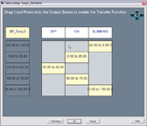
The Table Lookup transfer function allows every possible combination of input values to be individually classified into output states. Each input combination can belong to only one output state and only one input may be valid at a time. Input combinations that are not associated with a category result in no change to the output state.

A typical example is to create a table lookup to turn a fan on (output state) when the system temperature is greater than 25’C (Input) and the fan is enabled (Input). The fan will be off if the temperature is less than 25’C or the fan is disabled.

